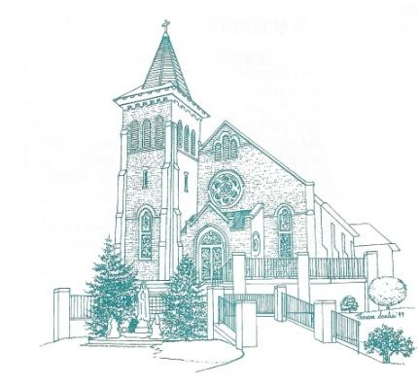
St. Mary’s School of Religion
Registration- Kindergarten- Grade 8
Classes Begin on September 6, 2023
All classes are held on the church grounds K-5th 4:00pm- 5:15pm 6-8th 7:30-8:30pm
↓ Father↓ | ↓Mother↓ | Students main mailing address↓
Last | Last | Street Address
First | First | City
Daytime Phone | Daytime Phone | Zip
Cell Phone | Cell Phone | Home Phone
E-mail- Print clearly | E-mail-print clearly
Emergency Contact | Phone | Relationship

↓ Child # 1 ↓ | ↓ Child # 2 ↓ | ↓ Child # 3 ↓
Last: | Last: | Last:
First | First: | First:
Middle: | Middle: | Middle:
Gender: M/ F | Gender: M/ F | Gender: M/ F
Date of Birth: | Date of Birth: | Date of Birth:
Grade in Sept. 2023: | Grade in Sept.2023: | Grade in Sept.2023:
School: | School: | School:
Sacramental Records  Baptism | Sacramental Records  Baptism | Sacramental Records  Baptism
Date: | Date: | Date:
Name of Church:  Is it Catholic? Y N | Name of Church:  Is it Catholic? Y N | Name of Church:  Is it Catholic? Y N
First Communion | First Communion | First Communion
Date: | Date: | Date:
Church: | Church: | Church:
City/State: | City/State: | City/State:
Is your child in grade 2 or older and needs 1st Communion? Y N | Is your child in grade 2 or older and needs 1st Communion? Y N | Is your child in grade 2 or older and needs 1st Communion? Y N
If yes, has your child completed one year of Religious Ed? Y N | If yes, has your child completed one year of Religious Ed? Y N | If yes, has your child completed one year of Religious Ed? Y N
Confirmation  Is your child in 8th Grade and making Confirmation this year? Y N | Confirmation  Is your child in 8th Grade and making Confirmation this year? Y N | Confirmation  Is your child in 8th Grade and making Confirmation this year? Y N
Special Needs | Special Needs | Special Needs
Allergies/Medical Conditions/ Medications/Learning Challenges? | Allergies/Medical Conditions/ Medications/Learning Challenges? | Allergies/Medical Conditions/ Medications/Learning Challenges?
Fee: $ 75.00 one child Make checks payable to St. Mary’s
$ 130.00 two children Mail to: St. Mary’s
$ 200.00 three or more children PO Box 67, Barnesville MD 20838
** There is a $25.00 sacrament fee for those children making their First Holy Communion or
Confirmation (Grades 7 & 8)
Any questions call Mrs. Smith at 301-651-3353 or at smithstmarysb@gmail.com
Parent Volunteers Needed
How is God calling you to serve? Our volunteers are the backbone of our parish and School of Religion. We cannot run our program without your help. Please help us!
Please check off which activities with which you are able to assist. We expect all families to help in some capacity. THIS SECTION IS NOT OPTIONAL!
_____ Catechist
_____ Assistant/Co Catechist
_____ Substitute Catechist __________afternoon program ______evening program
_____ Assist in the Christmas Eve Nativity. Parent must be available during afternoon
Class times 12/06, 12/13, 12/20 and attend Christmas Eve Mass at 4:00pm.
______Co- Chair the two Craft Sundays- December 3rd and March 3rd .
_____ Help on committee to prepare Advent and Christmas crafts for children to do after all
Masses on December 3rd .
____ Help on committee to prepare Lenten crafts for the children to do after all masses March 3rd .
_____Help serve refreshments after Confirmation
(Not a Confirmation parent)
_____Help serve refreshments after First Holy Communion on May 4th at 11:00am.
(Not a parent of a child receiving Holy Communion)

