VACATION BIBLE CAMP
“RISE UP”
“CALLED IN YOUR DREAMS”

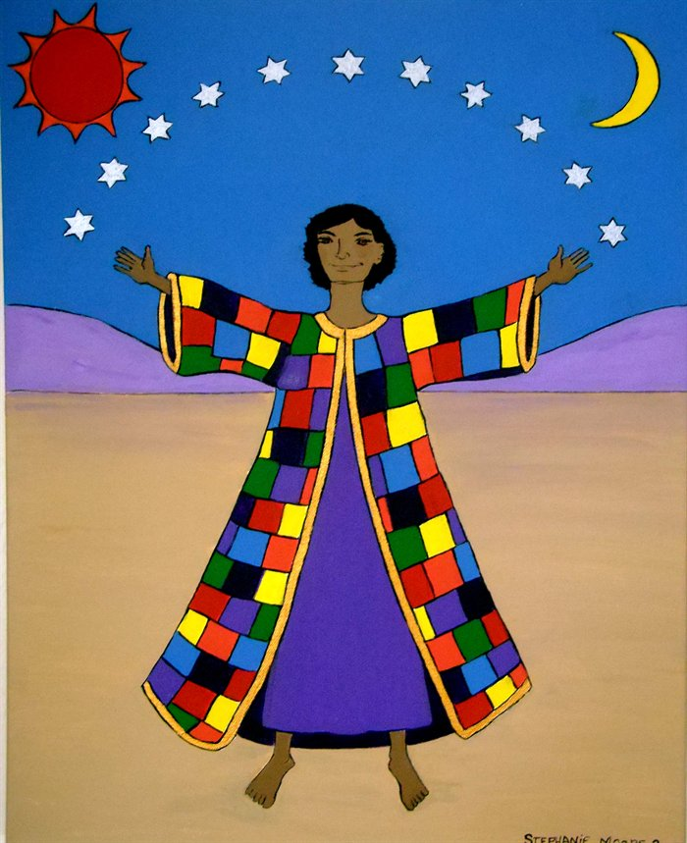

St. Mary’s Shrine

Barnesville, MD.
July 9-13, 2018
9:30 AM – NOON
3 years to 6th Grade

NAMES OF CHILDREN AGE GRADE IN
SEPTEMBER

All Adult staff must be in compliant with the Archdiocese Child Protection Policy
Adult teachers and helpers are needed
Jr. and Sr. high school aides are welcome and needed.
Assistant Director to help run Bible School call Brenda Murtha 301-452-2581
breezegs@verizon.net
Please complete the form on the back and mail or email it to Brenda Murtha 17309 Whitaker Road, Poolesville, MD. 20837
PLEASE REGISTER AS EARLY AS POSSIBLE SO THAT WE HAVE THE NECESSARY SUPPLIES AVAILABLE FOR YOUR CHILD.

I would like to help on (days)_____________________________________________

PARENTS NAME: `

ADDRESS:

PHONE _________________CELL___________________

EMAIL__________________________________________

PARISH_________________________________________

EMERGENCY CONTACT: RELATIONSHIP

PHONE:

______________________________________

FOOD ALLERGIES OR SPECIAL MEDICAL NEEDS:

Please Plan to join us on Friday at 11:30 AM for our closing performances followed by a Hot Dog Picnic Lunch

THIS YEAR WE ARE PROVIDING T-SHIRTS. PLEASE LIST BELOW THE SIZES YOU NEED

YS___YM___YL___AS___AM___AL___AXL___OTHER____

